**CBS810 Lab 1: Introduction to R**

Shi Chen schen31@ncsu.edu

**Crawley, M.J. (2007) The R Book, Wiley, UK.**

**Learning objectives:**

• Download, install, and run R

• Perform basic operations

• Perform basic data analysis

• Learn how to get help

• Explain the different data types in R

**Download, Install, and Run R Download R**

[**http://www.r-project.org/**](http://www.r-project.org/)

**Install R Run R**

R, RStudio, or command-line

**Stop R**

Normal: q() or quit()

Abnormal: Ctrl+C

**Basic Operations in R**

**Screen Prompts: Not “Point and Click”**

log(42/7.3)

[1] 1.749795

5+6+3+6+4+2+4+8+ + 3+2+7

[1] 50

2+3; 5*7; 3-7

[1] 5 [1] 35 [1] -4

**Built-in Functions: Convenient Companions**

log(10)

[1] 2.302585

exp(1)

[1] 2.718282

log10(6)

[1] 0.7781513

log(9,3)

[1] 2

sin(pi/2)

[1] 1

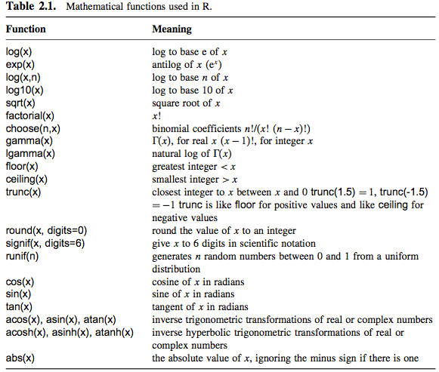

**Assignments: Difference between <-, =, and ==**

x<-5

x=5

x==5

**Operators: Important Operations and Links**

**+ - * / %% ^ Arithmetic**

**> >= < <= == != Relational**

**! & | Logical**

**<- Assignment**

**Vector: for Data Analysis**

**Vector Functions**

x <- 10:16

x <- c(10, 11, 12, 13, 14, 15, 16)

max(x)

min(x)

sum(x)

mean(x)

var(x)

max(x)

mean(x)

median(x)

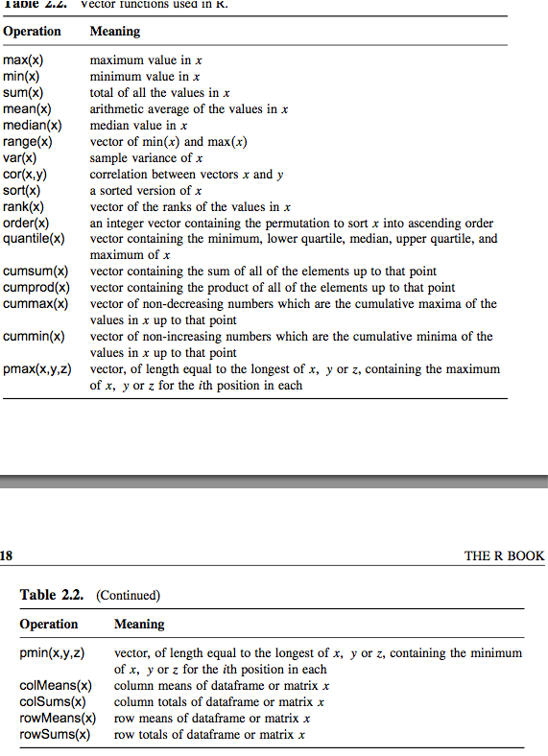

**Subscripts and Indices**

x<-0:10

x[1]

x[1:3]

x[x<5]

x<5

**Selecting and Trimming Vector**

x<- c(5,8,6,7,1,5,3)

x[4]

[1] 7

z <- x[-1]

  z

  [1] 8 6 7 1 5 3

z <- x[-c(1:2)]

**Matrix and Array: from 2-D to 3-D (and n-D)**

x<-matrix(c(1,0,0,0,1,0,0,0,1),nrow=3)

x

x[1,1]

1

x[1,]

1 0 0

x[,2]

0 1 0

x<-array(rnorm(2*3*4),dim=c(2,3,4))

**Data Analysis in R Data Types**

# Character Strings (vs Numerical):

x<-1

y<-"1"

x+y

# Logical: x<-1; x>0

x<-c(T,T,F)

**Data Frame**

A *dataframe* is an object with rows and columns (a bit like a matrix). The rows contain different observations from your study, or measurements from your experiment. The columns contain the values of different variables.

t<-c(0:10)

I<-c(0,1,48,25,10,4,2,1,0,0,0)

sir.out<-data.frame(t,I)

sir.out

**Data Visualization: Plot it!**

attach(sir.out)

plot(t,I)

# make it a little prettier

plot(t, I, type= "l", xlab= "Time", ylab= "Prevalence",main= "SIR Model Output",lwd=2,cex=1.5,cex.axis=1.5,cex.lab=1.5)

**Don’t Panic and Get Help: the (R)escue**

help(ks.test)

R manual

<http://cran.r-project.org/manuals.html>

R mailing list